SEE EDIT BELOW_- ADDED IMAGE TO MAKE IT COLORFUL ON CELLPHONE
___ PEMF - Holistic Approach
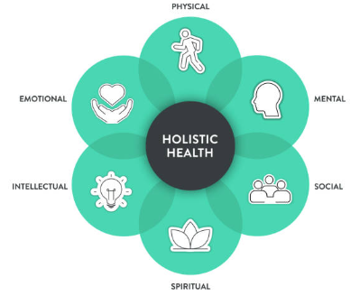 | A holistic approach to health considers and integrates the mental, emotional, physical, intellectual, social, and spiritual aspects of a person, viewing them as interconnected parts of overall well-being  This perspective recognizes that imbalances in one area can affect others. PEMF is a holistic approach to promote a state of total wellness  Holistic health using PEMF, aims to achieve overall well-being by addressing interconnected aspects of life, such as mental health, emotional health, intellectual health, physical health, social health and spiritual health

PEMF - Holistic Approach
PEMF - Holistic Approach  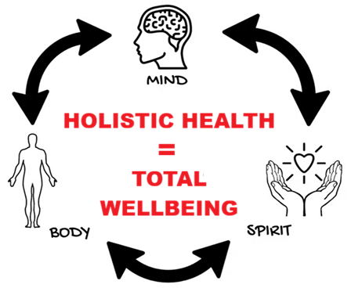  A holistic approach to health considers and integrates the mental, emotional, physical, intellectual, social, and spiritual aspects of a person, viewing them as interconnected parts of overall well-being | PEMF - Holistic Approach    A holistic perspective is a way of viewing a person as a complete and interconnected whole.  This perspective recognizes that imbalances in one area can affect others. PEMF is a holistic approach to promote a state of balance and total wellness | PEMF - Holistic Approach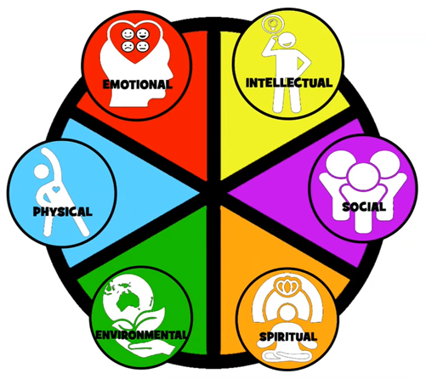  Holistic health using PEMF, aims to achieve overall well-being by addressing interconnected aspects of life, such as mental health, emotional health, intellectual health, physical health, social health and spiritual health

